Stem cell breakthrough reverses infertility after cancer

By Sarah Knapton, Science Editor12:01AM BST 22 Oct 2015

Scientists from Egypt's Mansoura Medical School show it is possible to restore fertility by injecting stem cells directly into the ovaries

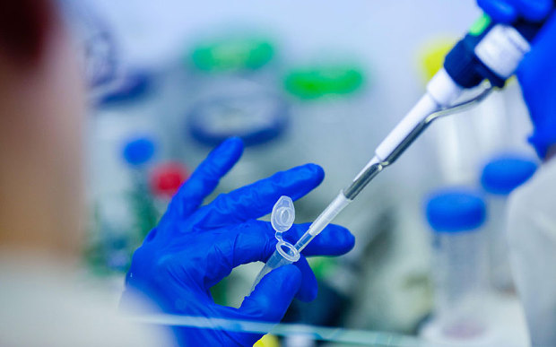
Mice who had suffered ovarian failure from chemotherapy were able to have large litters after treatment.
Cancer patients made infertile by chemotherapy have been offered new hope after scientists succeeded in reversing the damage caused to eggs for the first time.
In a landmark breakthrough hailed as "phenomenal" by fertility experts, researchers from Egypt and the US showed that injecting stem cells into ovaries can bring them back to life.
Chemotherapy is toxic to the ovaries, destroying eggs and ovarian tissue and triggering early menopause in some women.
• IVF women third more likely to develop ovarian cancer
Many younger women are now advised to freeze their eggs before undergoing cancer treatment, but in urgent cases there is often not time.
Now scientists have shown it is possible to restore fertility by injecting stem cells directly into the ovaries.
"This is very exciting piece of research that adds to our understanding of how cells differentiate to become egg stem cells."
Dr Stuart Lavery
Although the procedure has only been carried out in mice so far, the results were so successful that the researchers say they are ready to move to human trials.
Mice who had suffered ovarian failure from chemotherapy were able to have large litters after treatment.
The new treatment offers hope to more than 20,000 women of childbearing age who are diagnosed with cancer each year, and could also help those suffering from early menopause and ovarian failure.
Lead researcher Dr Sara Mohamed, of Mansoura Medical School in Egypt, said she had come up with the idea after meeting a 22-year-old cancer patient who was at risk of infertility from chemotherapy.
"It was a very emotional for me so I decided to pursue it and work on it to figure it out," she said.
"It a very common problem based on statistics of cancer female diagnosis every year.
"We inject stem cells in the ovaries of mice which had chemotherapy and were damaged and we got very good ovarian function restoration in form of follicle number, hormonal production and finally getting pregnant and having new pups which was our ultimate goal.
"We are now working on translating that into clinical trials (for humans). This approach carries high promise to women with chemotherapy-induced and potentially other types of premature ovarian failure."
In the trial involving 18 mice, one group were given chemotherapy and then ovarian injections of bone marrow stem cells, while another group had ovarian injections of saline. A third, control, group, had saline injections without the preceding chemotherapy.
Within a week researchers saw a boost in oestrogen, an essential hormone in ovulation, in the stem cell group followed by regeneration in ovarian tissue after a fortnight and an increase in the number of follicles.
Follicles produce the hormones oestrogen and progesterone and each carry a single egg which they release at ovulation.
The mice who had suffered ovarian failure were able to go on to have large litters of pups while those who had saline injections struggled.
Consultant Gynaecologist Dr Stuart Lavery, of Imperial College, said: "This is very exciting piece of research that adds to our understanding of how cells differentiate to become egg stem cells.
"Clearly, there remains an enormous amount of work to see whether these results would be transferable into humans.
"But it does provide some realistic hope that post-chemotherapy patients who have been made menopausal could one day restore ovarian function and possibly fertility."
The researchers are now hoping to move to human trials using umbilical cord or even embryonic stem cells although they will still have to convince regulators the procedures are safe.
Recent trials to stimulate stem cells in the ovaries were banned by the Food and Drug Agency (FDA).
Currently women diagnosed with cancer can be be offered egg freezing, or even early stage IVF, before chemotherapy.
But many trusts have cut IVF funding and women are sometimes denied cryopreservation. The new therapy would give peace of mind for women that something could be done to reverse the damage caused by chemotherapy.
And because the new technique regenerates ovarian tissue the new eggs could be even healthier than they were before chemotherapy, experts have suggested.
Women are born with all their eggs but they degrade over time. Stem cells have the potential to make eggs brand new again.

Dr Geoffrey Trew, consultant in Reproductive Medicine and Surgery at Hammersmith Hospital, London, said: "Fertility-wise, if this works it would be stupendous.
"Certainly it does appear promising and anything you can do to regenerate and ovary is a good thing.
"Theoretically if you are regenerating the ovary you should be getting better quality eggs.
"Clearly we're not here yet, and it's good that the researchers are not over-claiming their findings, but it's a great proof of concept."
Dr Edgar Mocanu, consultant gynaecologist at Rotunda Hospital in Dublin and board member of the International Federation of Fertility Societies, said: "This could open phenomenal opportunities for women.
"Millions of women around the world undergo cancer treatment and some of them will become infertile through ovarian failure.
"While cancer survival rates have increased dramatically, to date there is no effective method of preventing infertility after chemotherapy. It could also open new avenues for the treatment of menopause induced health issues."
"This approach carries high promise to women with chemotherapy-induced and potentially other types of premature ovarian failure."
Lead researcher Dr Sara Mohamed
Dr Owen Davis president of the American Society for Reproductive Medicine: "If this experimental treatment can be translated to women who have lost ovarian function from chemotherapy, it will be a great advance.
"Restoring ovarian hormone production, follicle development and fertility to chemotherapy patients is a potential new application for bone marrow donation that could help many women."
Coventry-based fertility expert Richard Kennedy, president-elect of the International Federation of Fertility Societies, said: "One of the really important messages for our cancer colleagues is that when men or women present for treatment, think about their fertility, think about the impact of the cancer treatment on their fertility.
• Thousands of cancer patients to be denied treatment
"That is a really important message because the majority of people with cancer now are living for five years or longer, and many are surviving their cancers, so thought about the long-term impact of treatment is important."
Katherine Taylor, of Ovarian Cancer Action, said: "This sounds very promising and we welcome any new research that helps us build on our knowledge of cancer and fertility. We look forward to seeing how this research advances in years to come."
The research was presented at the annual sheeting of then American Society for Reproductive Medicine in Baltimore.

OVARIAN CANCER

The symptoms
- Persistent stomach pain
- Persistent bloating or increased stomach size
- Difficulty eating or feeling full quickly
- Needing to urinate more frequently
If these symptoms started in the last 12 months, are unusual, and happen frequently and regularly, visit your GP.

IN NUMBERS

Cancer

2.5 million
Number of people living with cancer in the UK

46%
Percentage of deaths due to cancer of the breast, lung, prostate and bowel (2012)

50%
Adults diagnosed with cancer survive for ten years or more (2010/11)

1 in 4
People facing poor health or disability after cancer treatment

28%
Cancer deaths caused by smoking

65+
Age group with highest risk of getting cancer

30
Number of children diagnosed with cancer every week

